
NARROGIN SENIOR HIGH SCHOOL
Department of Crime Investigation

Case Number: ………………………………………………………… Date of report submission: ……………………………………
Investigating Detective: ……………………………………………………………………………………………………………………………….
Investigating Office: ……………………………………………………………………………………………………………………………………..
Chief Forensic Officer in Charge: ………………………………………………………………………………………………………………….

Discovery of the Deceased
Date of Discovery: …………………………………………………………………………………………………………………………………………
Discovers: ……………………………………………………………………………………………………………………………………………………..
Weather Conditions: …………………………………………………………………………………………………………………………………….
Summarise how the body was found by the discovers, and what it was they thought they had found.
…………………………………………………………………………………………………………………………………………………………..…………………………………………………………………………………………………………………………………………………………………………………………………………………………………………………………………………………………………………………………………………………………………………………………………………………………………………………………………………………………………………………………………
How did the discovers think the person had died?
………………………………………………………………………………………………………………………………………………………………………………………………………………………………………………………………………………………………………………………………………………………………………………………………………………………………………………………………………………………………………………………
Describe what happened when the Austrian police arrived at the scene, and the consequences of their use of the jackhammer.
………………………………………………………………………………………………………………………………………………………………………………………………………………………………………………………………………………………………………………………………………………………………………………………………………………………………………………………………………………………………………………………………………………………………………………………………………………………………………………………………………………………………………………………………………………………………………………………………………………………………………………………………………
Describe what happened when hikers and official police arrived at the scene, the consequences of their actions, and what other items they discovered with the body.
………………………………………………………………………………………………………………………………………………………………………………………………………………………………………………………………………………………………………………………………………………………………………………………………………………………………………………………………………………………………………………………………………………………………………………………………………………………………………………………………………………………………………………………………………………………………………………………………………………………………………………………………………

What environmental factors caused the body to be exposed and consequently found?
………………………………………………………………………………………………………………………………………………………………………………………………………………………………………………………………………………………………………………………………………………………………………………………………………………………………………………………………………………………………………………………………………………………………………………………………………………………………………………………………………………………………
What happened to the body when it was placed in the morgue?
………………………………………………………………………………………………………………………………………………………………………………………………………………………………………………………………………………………………………………………………………………………………………………………………………………………………………………………………………………………………………………………………………………………………………………………………………………………………………………………………………………………………
How did Dr Spindler treat the body? What conclusions did he draw after examining the axe found with the body?
………………………………………………………………………………………………………………………………………………………………………………………………………………………………………………………………………………………………………………………………………………………………………………………………………………………………………………………………………………………………………………………………………………………………………………………………………………………………………………………………………………………………………………………………………………………………………………………………………………………………………………………………………………………………………………………………………………………………………………………………………………………………………………………………………………………………………………………………………………………………………………………………………………………
Make notes on any other factors of the discovery that you think are important or interesting.
………………………………………………………………………………………………………………………………………………………………………………………………………………………………………………………………………………………………………………………………………………………………………………………………………………………………………………………………………………………………………………………………………………………………………………………………………………………………………………………………………………………………………………………………………………………………………………………………………………………………………………………………………………………………………………………………………………………………………………………………………………………………………………………………………………………………………………………………………………………………………………………………………………………………………………………………………………………………………………………………………………………………………………………………

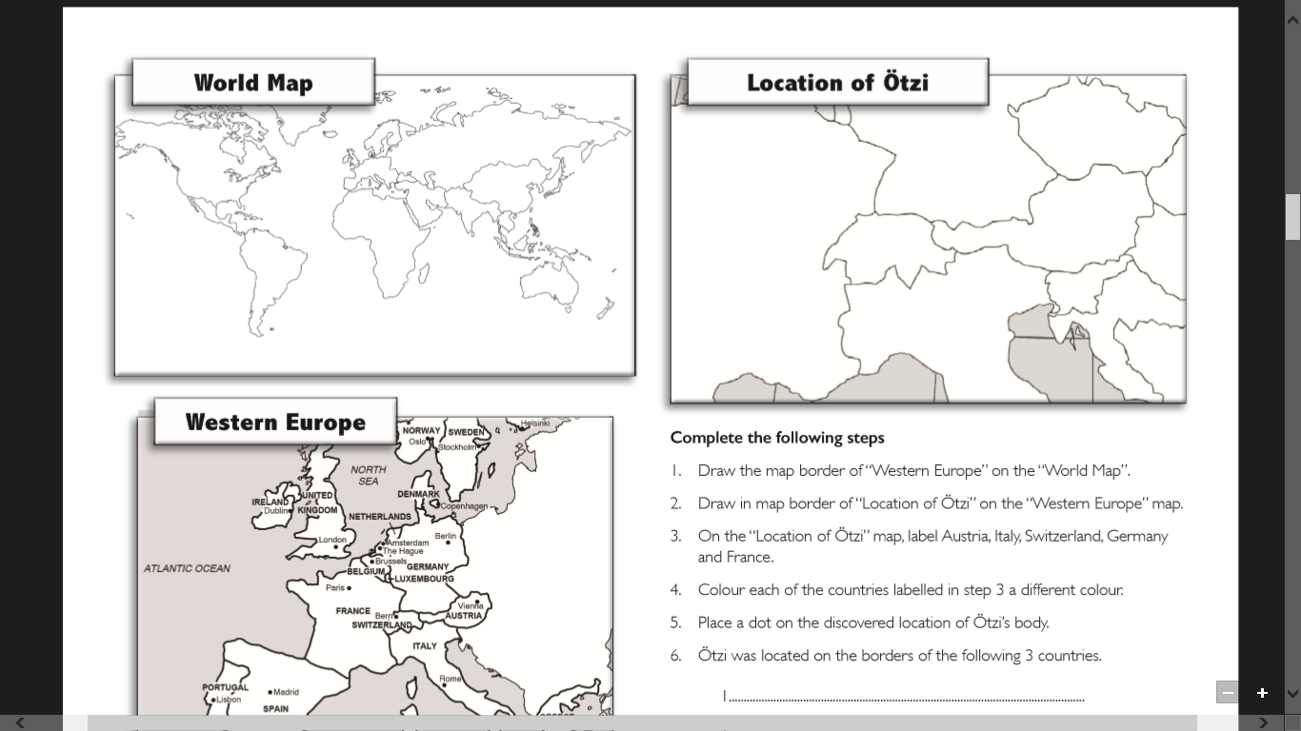

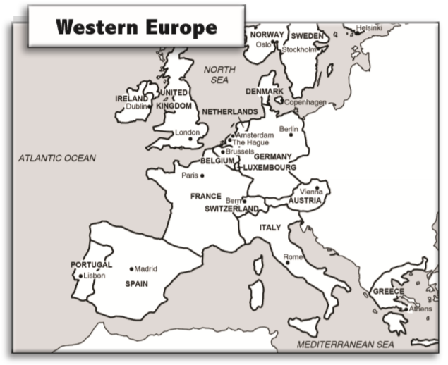
Complete the following steps:
- Draw the map border of “Western Europe” on the “World Map”.
- Draw in the map border of “Location of Ötzi” on the “Western Europe map.
- On the “Location of Ötzi” map, label Austria, Italy, Switzerland, Germany and France.
- Colour each of the countries labelled in step 3 a different colour.
- Place a dot on the discovered location of Ötzi’s body.
- Ötzi was located on the borders of the following 3 countries.
- ………………………………………………..
- ………………………………………………..
- ………………………………………………..

Personal Profile
Personal Details
Gender …………………………………………………
Age at time of Death ………………………………………………………. Date of Death …………………………………………
Height …………………………………………………………………………… Hair Colour …………………………………………….
Physical Condition…………………………………………………………………………………………………………………………………………
Deceased is also known as 1. ………………………………………… 2. ……………………………………………………………
Marking on the body ………………………………………………………………………………………………………………………………………………………………………………………………………………………………………………………………………………………………………………………………………………………………………………………………………………………………………………………………………………………………………………………
Where is it likely that the deceased person lived?
………………………………………………………………………………………………………………………………………………………………………………………………………………………………………………………………………………………………………………………………………………
What scientific evidence supports the theory of where the deceased person lived?
………………………………………………………………………………………………………………………………………………………………………………………………………………………………………………………………………………………………………………………………………………
Diet Details
How was the diet of the deceased determined?
………………………………………………………………………………………………………………………………………………………………………………………………………………………………………………………………………………………………………………………………………………
Modern Diet | Ötzi’s Diet
Personal Profile
Possible Occupation/Role | Pros | Cons
1.
2.
3.
4.
5.
Clothing
Name of item and image | Materials item was made from | Item’s use
1.
2.
3.
4.
5.
6.
7.
Equipment
Name of item and image | Materials item was made from | Item’s use
1.
2.
3.
4.
5.
6.
Equipment
Name of item and image | Materials item was made from | Item’s use
7.
8.
9.
10.
11.
12.
Proposed Causes of Death
Outline each theory and how the evidence and/or science supports the theory.

Theory 1 (tick a box)

………………………………………………………………………………………………………………………………………………………………………………………………………………………………………………………………………………………………………………………………………………………………………………………………………………………………………………………………………………………………………………………………………………………………………………………………………………………………………………………………………………………………………………………………………………………………………………………………………………………………………………………………………………………………………………………………………………………………………………………………………………………………………………………………………………………………………………………………………………………………………………………………………………………………………………………………………………………………………………………………………………………………………………………………………………………………………………………………………………………………………………………………………………………………………………………………………………………………………………………………………………………………………………………………………………………………………………………………………………………………………………………………………………………………………………………………………………………………………………………………………………………………………………………………………………………………………………………………………………………………………………………………
Theory 2 (tick a box)

………………………………………………………………………………………………………………………………………………………………………………………………………………………………………………………………………………………………………………………………………………………………………………………………………………………………………………………………………………………………………………………………………………………………………………………………………………………………………………………………………………………………………………………………………………………………………………………………………………………………………………………………………………………………………………………………………………………………………………………………………………………………………………………………………………………………………………………………………………………………………………………………………………………………………………………………………………………………………………………………………………………………………………………………………………………………………………………………………………………………………………………………………………………………………………………………………………………………………………………………………………………………………………………………………………………………………………………………………………………………………………………………………………………………………………………………………………………………………………………………………………………………………………………………………………………………………………………………………………………………………………………………………………………………………………………………………………………………………………………………………………………………………………………………………………………………………………………………………………………………………………………………………………………………
Theory 3 (tick a box)

………………………………………………………………………………………………………………………………………………………………………………………………………………………………………………………………………………………………………………………………………………………………………………………………………………………………………………………………………………………………………………………………………………………………………………………………………………………………………………………………………………………………………………………………………………………………………………………………………………………………………………………………………………………………………………………………………………………………………………………………………………………………………………………………………………………………………………………………………………………………………………………………………………………………………………………………………………………………………………………………………………………………………………………………………………………………………………………………………………………………………………………………………………………………………………………………………………………………………………………………………………………………………………………………………………………………………………………………………………………………………………………………………………………………………………………………………………………………………………………………………………………………………………………………………………………………………………………………………………………………………………………………………………………………………………………………………………………………………………………………………………………………………………………………………………………………………………………………………………………………………………………………………………………………

